FGM Risk Incidence, Nigeria 2024
Bayesian spatiotemporal estimates of cutting risk by birth cohort, state, and ethnicity, from the 2024 Demographic and Health Survey
- Introduction
This study estimated FGM risk incidence in Nigeria using the 2024 DHS-8 data. We analysed age at cutting and birth cohorts to assess changes in FGM risk across generations. The study builds on the original cohort-based time to event framework, applying a discrete-time hazard model and a Bayesian spatial temporal model to estimate FGM risk across regions.
- Datasets used
This study uses the following variables extracted from Nigeria’s 2024 DHS data:
- Respondent own circumcision status(g102)-to model the fgm event
- Respondent’s age at circumcision(g106)-the event time, becomes time in time to event framing.
- Daughters’ circumcision status(g121), daughter age at circumcision(g122)- The daughter roster gives us information about younger girls and whether they have already been cut. This helps us understand FGM risk among recent generations more accurately and reduces the risk of making their FGM risk look lower than its actual level.
- Respondent’s year of birth(v010)-for the birth cohort mapping
- Respondents current age(v012)-censoring age for anyone not cut
- Region(v024)
- Urban/ Rural(v025)-used as a covariate
- Ethnicity(v121)-used as a covariate
In summary, a total of 39,050 women aged 15–49 was interviewed. Of these, 23,474 women had a known FGM status. The daughter roster provided an additional 23,683 daughter records, resulting in 47,157 FGM records.
After excluding 2,473 FGM-positive records with missing or invalid age at cutting, 44,684 records were retained for the risk-incidence analysis. These included 37,328 records with no recorded FGM event and 7,356 records with a recorded FGM event.
- Methodology
- Censoring and Risk Set
A three-year-old girl who has not been cut is observed only up to age three, while a 49-year-old woman who has not been cut is observed upto age 49. Both are coded as event = 0 but they contribute information for different lengths of time.
An uncut person is considered at risk only during the ages they have been observed. “At risk” does not mean that the person is expected to be cut; it simply means that the event has not yet occurred and observation is ongoing.
This is why the analysis uses both time and fgm_event. Where time is the age at cutting or observation event.
- Kaplan Meier Baseline
A Kaplan–Meier estimator was used as a baseline before fitting the formal hazard models. Age at cutting was treated as the event time. Individuals who had not experienced FGM at the time of the survey were treated as right censored. Kaplan–Meier curves were generated separately for self-reported and daughter-reported records and grouped by five-year birth cohorts.
For each cohort, the cumulative probability of FGM was estimated at ages 1, 2, 5, 8, 10, 15, and 18 years.The resulting estimates were used as a descriptive reference and later compared with the hazard and spatial models. It is important to note that the Kaplan–Meier estimates were unweighted and do not account for the DHS cluster design, they were therefore interpreted as descriptive rather than nationally representative.
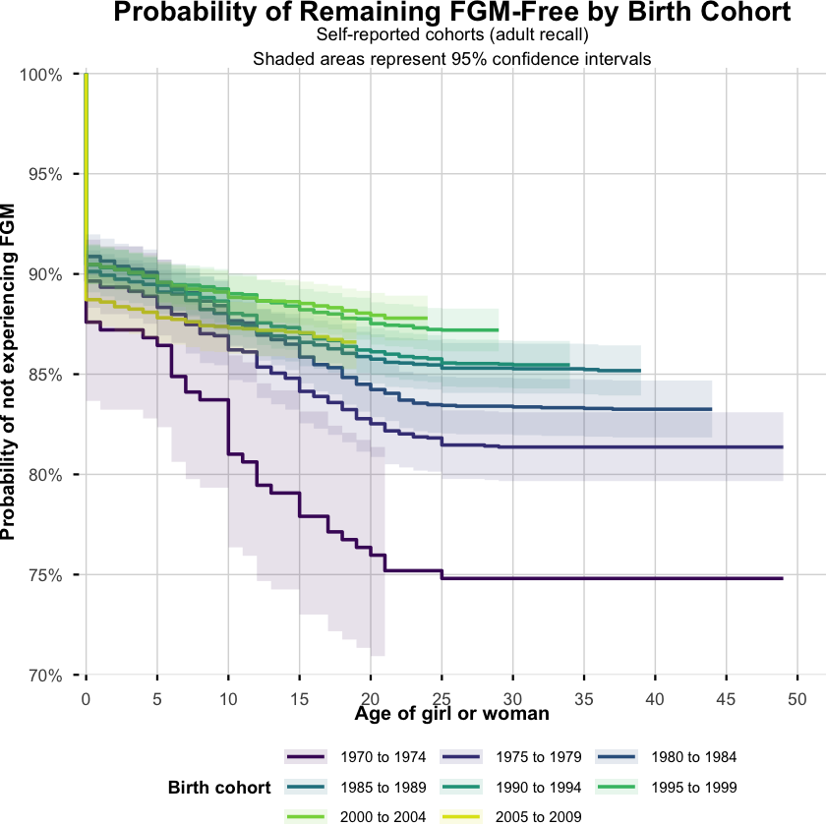
Among self-reported individuals, the 1970–1974 cohort appears most susceptible to FGM. FGM risk generally decreases across successive birth cohorts.
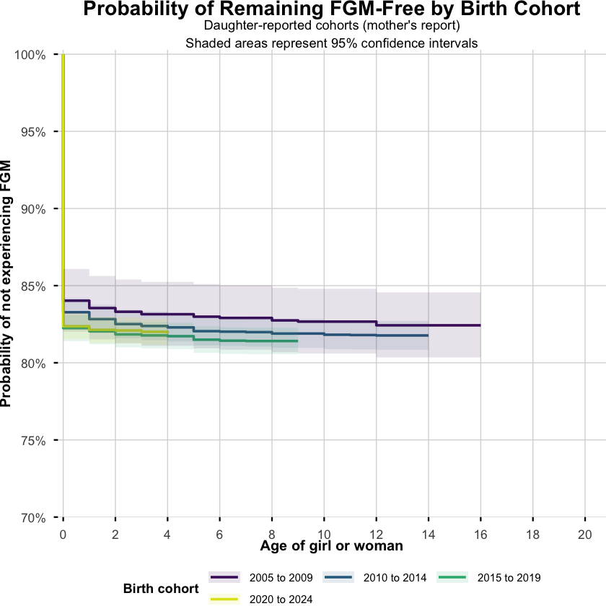
For daughter reported cohorts, the results suggest a slight decline in FGM risk across recent cohorts, but the differences are small. The youngest cohorts should be interpreted cautiously because many individuals have not yet completed their risk period.
The sharp drop at age 0 occurs because many FGM events are recorded as happening at birth or within the first year of life. Since the Kaplan–Meier curve begins at 100% FGM-free, these early events cause an immediate fall at the start of the graph. The drop is especially large in the daughter-reported results because mothers report that many girls were cut very early. Therefore, the sharp line reflects the concentration of reported cutting at age 0, rather than a plotting error.

- Discrete time hazard model
This model was used to estimate the probability that a person experiences FGM at a specific age, given that she has not been cut previously. A survey weighted discrete time hazard model was adopted to estimates FGM risk at each age, adjusting for birth cohort, age, region, residence, ethnicity, and reporting type, while applying survey weights. This model recognizes that younger girls have had less time to experience FGM than older women. For example, a 3-year-old and a 45-year-old cannot be treated as having the same level of risk simply because neither has been cut.

Results summary
Factor | Key Result | Interpretation
Age | Negative and highly significant | FGM risk decreases as age increases, indicating that cutting mainly occurs at younger ages.
Birth cohort | Risk generally decreases across newer cohorts | FGM appears to be declining across generations.
Most affected cohort | 1970–1974 | This cohort has the highest risk. It is the reference group.
Lowest estimated risk | 2000–2004 | This cohort shows the largest reduction in risk compared with 1970–1974.
Recent cohorts | 2005–2019 show lower risk | The decline appears to continue, although the youngest cohorts have limited observation time.
2020–2024 cohort | Not statistically significant | The estimate should be interpreted cautiously because many individuals are still young.
Urban/rural residence | Urban residence has lower risk | FGM risk is significantly lower among urban respondents than rural respondents.
Reporting type | Self-reported records have lower risk | Self-reported cases show lower estimated risk than daughter-reported cases.
Birth cohort (relative to 1970–1974, the reference):
Cohort | Coefficient | p-value
1975–1979 | −0.31 | 0.096
1980–1984 | −0.44 | 0.014
1985–1989 | −0.50 | 0.004
1990–1994 | −0.63 | <0.001
1995–1999 | −0.79 | <0.001
2000–2004 | −0.87 (lowest point) | <0.001
2005–2009 | −0.68 | <0.001
2010–2014 | −0.67 | <0.001
2015–2019 | −0.64 | 0.002
2020–2024 | −0.30 (closest to the 1970s baseline) | 0.142 (not significant)
Negative number means lower risk while a positive number means higher risk. Ethnicity is one of the strongest predictors in the model with a coefficient of -4.28 and a p<0.0001.
- Spatial Small Area Estimation
Spatial small-area estimation is used to produce more stable estimates in areas with small sample sizes. Bayesian spatial smoothing is implemented using INLA combining region-level information, birth cohort or period effects and neighboring area information. The implementation borrows statistical approach used by SUMMER particularly the use of a logit scale in risk estimation and application of precise weighting so estimates based on larger and reliable samples receive greater influence.
A BYM2 spatial random effect allows neighboring areas to borrow statistical strength from one another.
The flow chart below shows how the hazard analysis supports the generation of the final subnational FGM risk maps. It shows the two pathways, the hazard model, which produces adjusted coefficients and statistical results, and the mapping workflow, which uses survey-weighted regional estimates to produce the final risk maps.
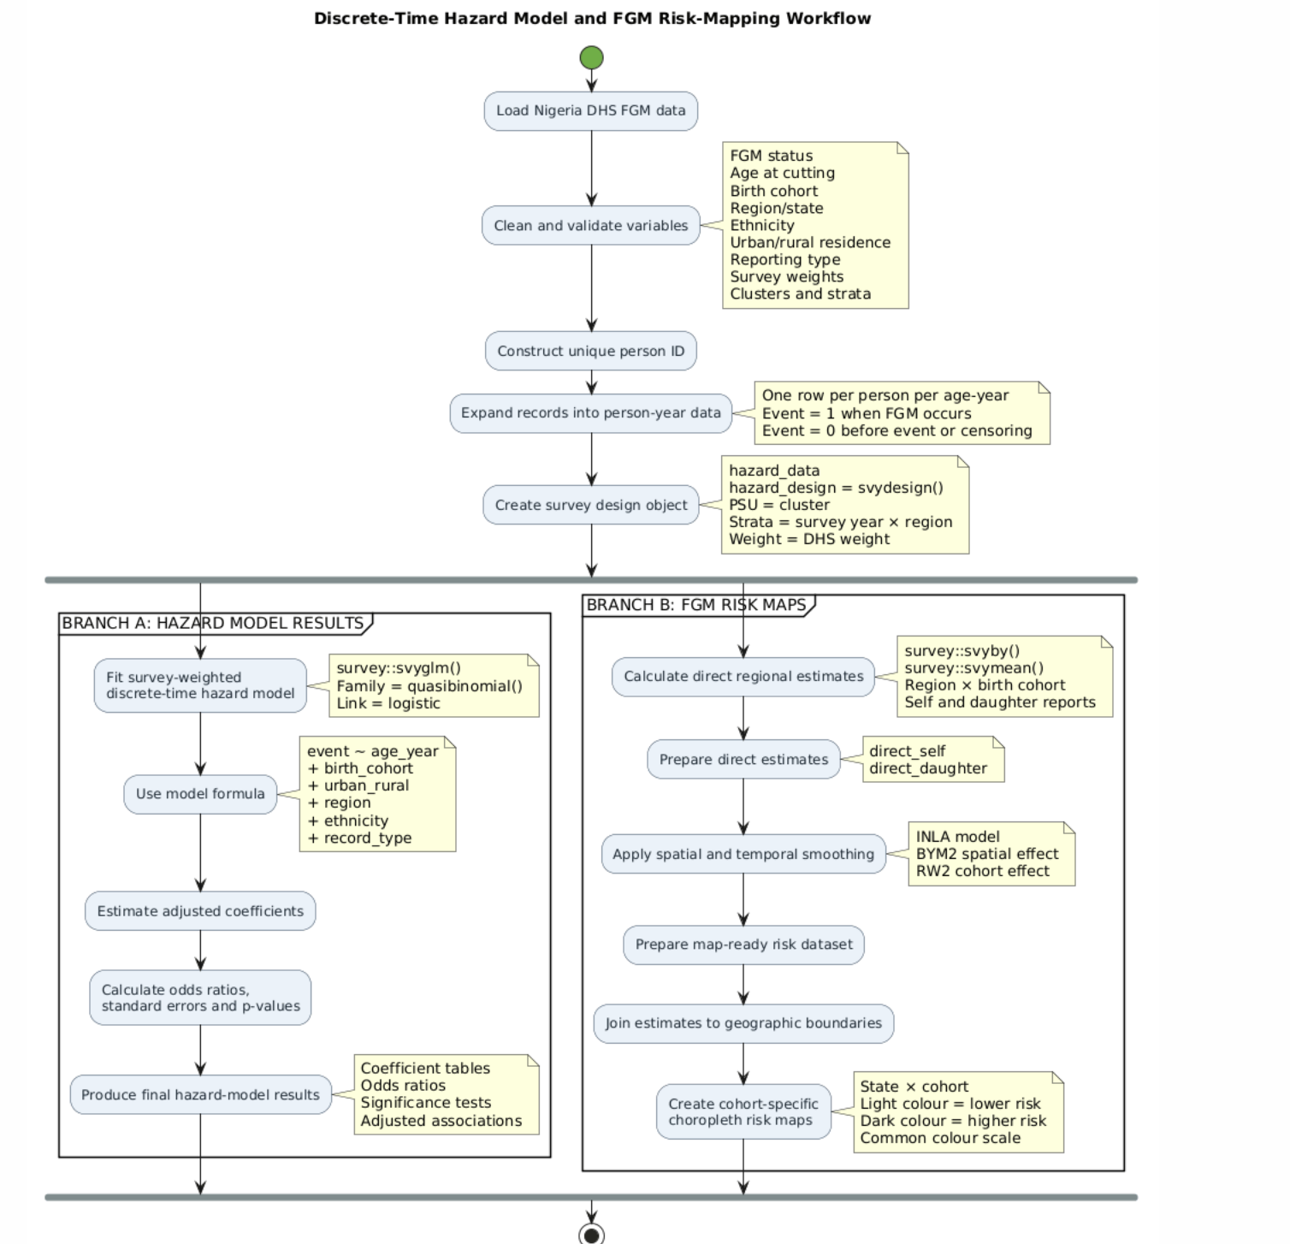
A detailed flow chart on how risk maps were generated
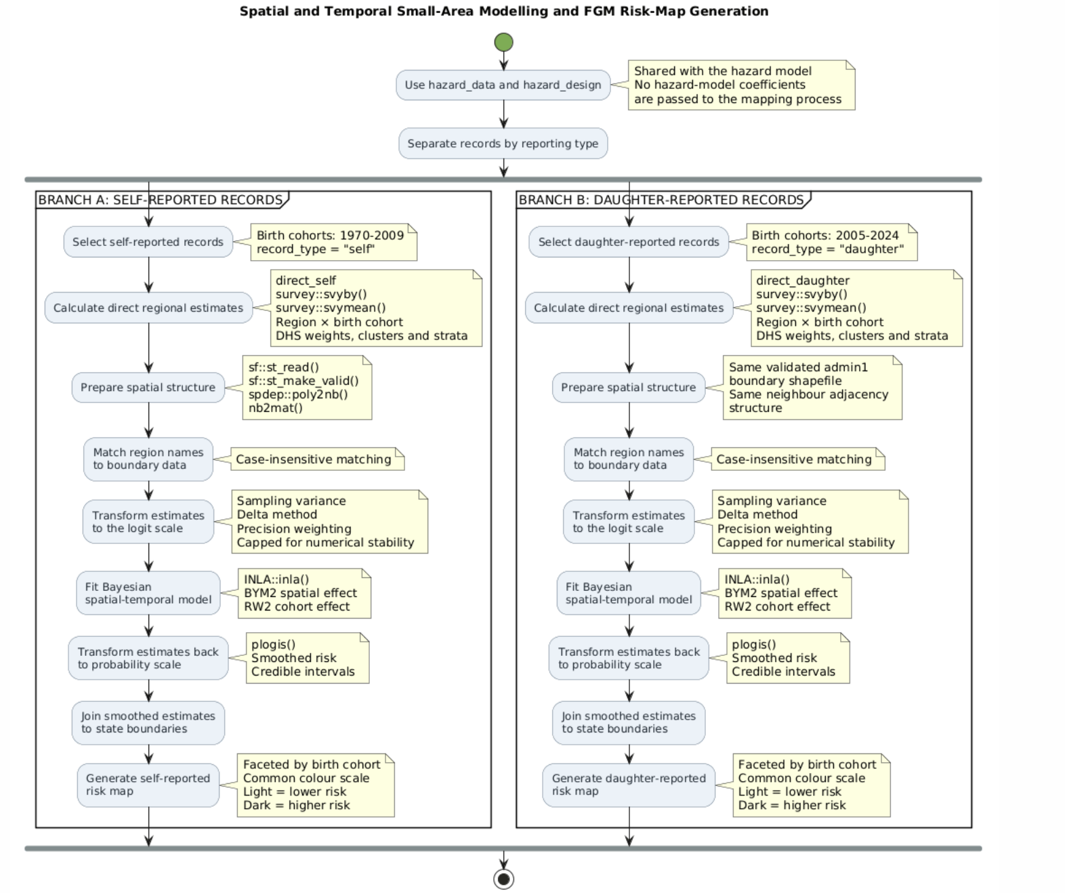
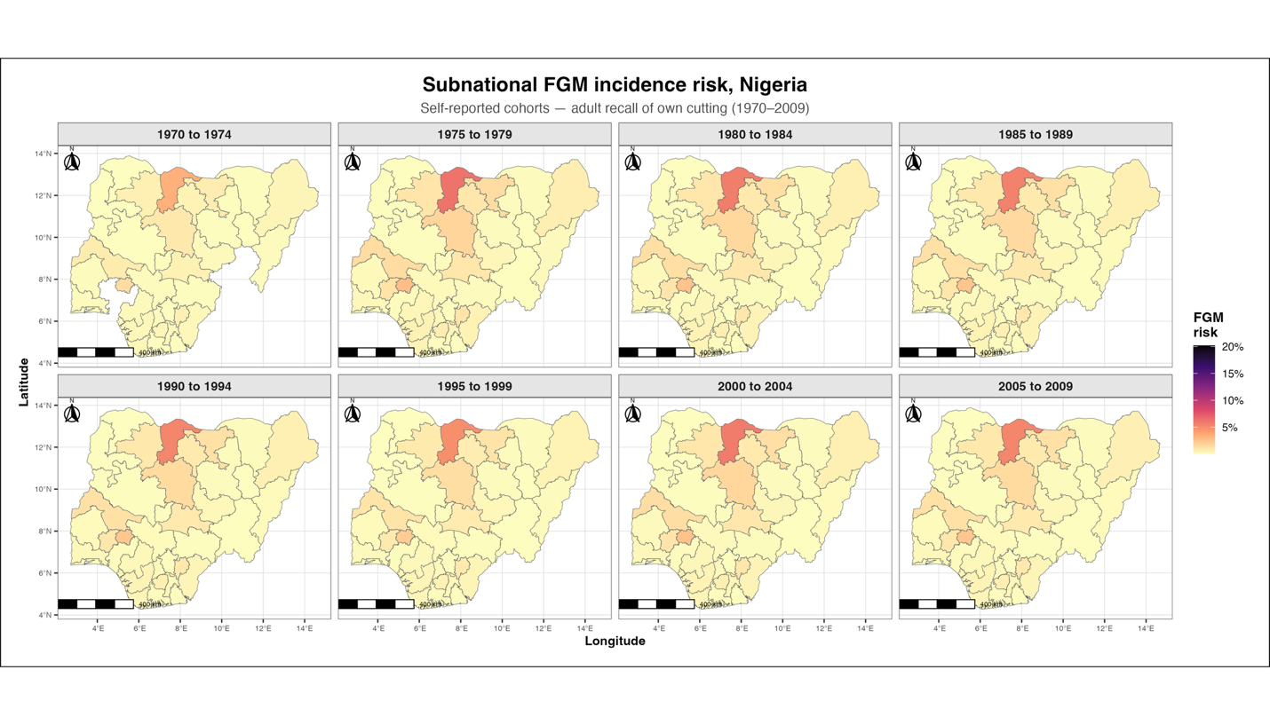
Katsina state consistently shows the highest FGM risk across every generation from 1970 through 2009. Most other states stay pale yellow across all eight panels, meaning risk has been consistently low and stable for them across 40 years. Hotspot states are a persistent, longstanding geographic pattern, not a recent development.
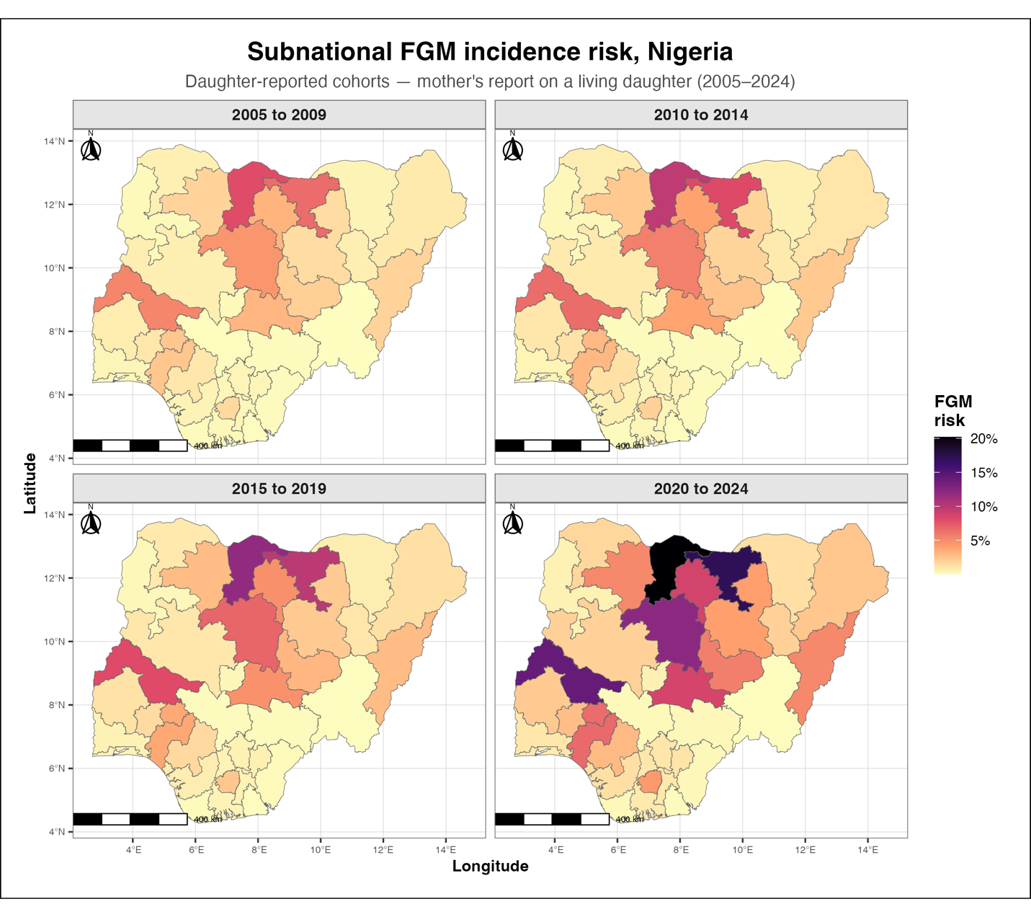
Daughter-reported FGM risk increases in both intensity and geographic spread across the recent cohorts, with the highest levels observed in 2020–2024. Risk is concentrated mainly in northern and north-central states but becomes more widespread in the latest cohort. This contrasts with the relatively stable geographic pattern observed in self-reported data. The difference may be related to the concentration of daughter-reported observations in early, high-risk ages or a recent increase in early cutting. The results should be interpreted as higher estimated risk among recent daughter-reported cohorts other than a conclusive increase in FGM related cases.
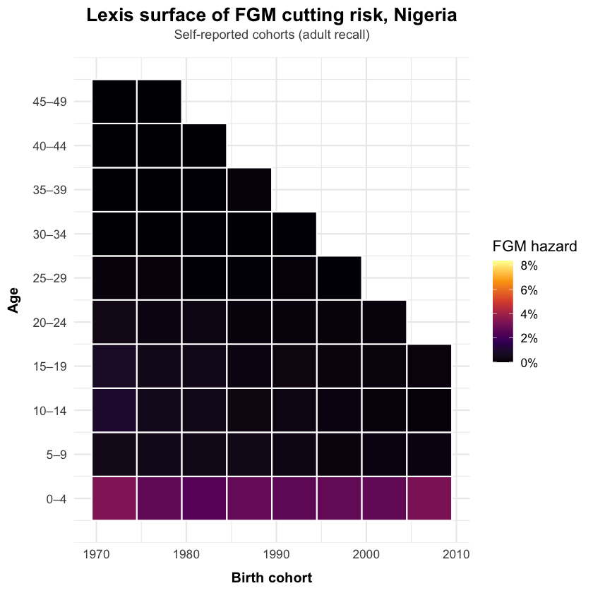
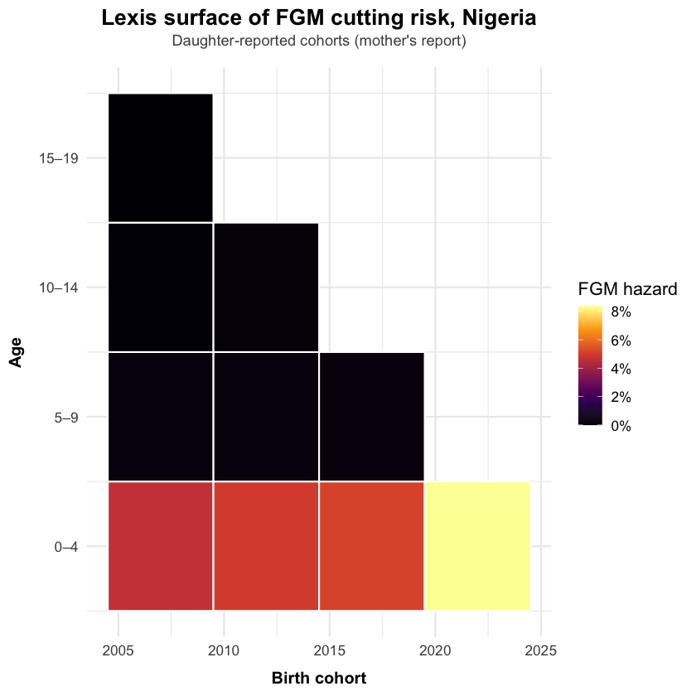
In the lexis heatmaps, nearly all risk is concentrated at the earliest ages.

Model Alignment and Cross checks
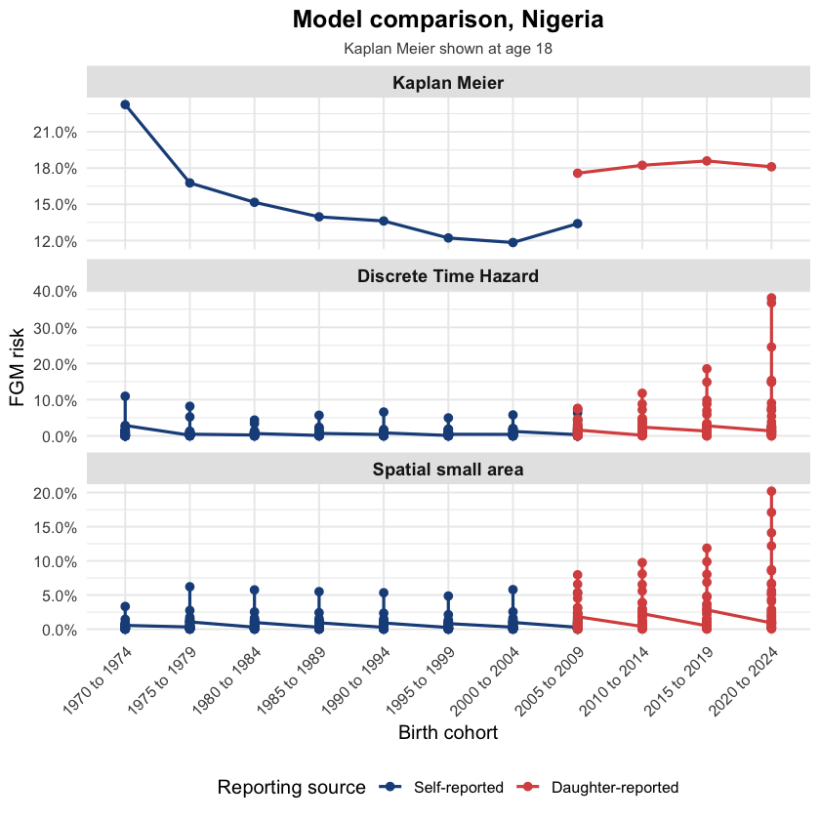
A comparison of the three methods shows a consistent pattern. Self-reported FGM risk declines across the 1990s–2000s birth cohorts, while daughter-reported risk is higher and more variable. The wider spread in the raw survey estimates reflects substantial state-level differences across the 37 points per cohort. Bayesian spatial smoothing reduces extreme outliers, lowering the maximum estimate from approximately 38% to 20%.
Additionally, a Random Survival Forest (RSF) model crosscheck was carried out to verify our findings. This model confirms that region and ethnicity are the strongest predictors of FGM risk, while urban/rural residence has a smaller effect. Its approximately 80% concordance shows good predictive discrimination. However, it cannot directly confirm the cohort trend shape or explain causality.

Attitude Incidence Mapping, Nigeria 2024
1. Introduction
We did not use multilevel_EM from unsae for risk incidence mapping and used BYM2 through SUMMER and INLA because risk incidence is a time to event outcome needing person month data with an age and period structure. Multilevel_EM only fits a single cross-sectional proportion with no time dimension, so it cannot represent that structure. BYM2 pairs spatial smoothing with a random walk over time, matching what the outcome actually requires.
We are again not using multilevel_EM from unsae for attitude incidence because many FGM clusters are small and contain only “Yes” or only “No” responses. This gives the multilevel_M2 model little variation and causes its variance estimates to become unstable and diverge. We will therefore use BYM2 with RW2.
2. Datasets used
This study uses the following variables extracted from Nigeria’s 2024 DHS data:
· Female circumcision, continued or stopped-g119
· Respondent status-g102
· Eduction-v106
· Wealth-v190
· Religion-v130
· Ethnicity-v131
· Urban or Rural-v025
· Region-v024
The analysis began with 39,050 women interviewed of which, 23,474 women passed the g100 skip gate, indicating that they had heard of female genital cutting. These women were asked about their own FGM status in g102 and their attitude toward continuation in g119.
Among those who passed the skip gate, 20,916 women provided a usable response to g119. This final group was used for the attitudinal analysis and state-level mapping.
3. Methodology
· Random. Forest Feature Importance
A random forest model with 500 trees was fitted to predict whether respondents support FGM continuation using the seven candidate predictors. Variables were ranked using Mean Decrease in Gini impurity, which measures how much each variable improves the model’s ability to classify responses.
Region was the most important feature, with the highest Mean Decrease in Gini value (976.42). This suggests that geographic location contributed most to predicting attitudes toward FGM continuation. Own FGM status was the second most important predictor (566.75), followed by ethnicity (395.10).
Variables with higher importance contributed more to prediction, while lower-ranked variables contributed less.

· Variance Inflation Factor
All the adjusted VIF values were below 2. The indicates there was no important multicollinearity among the predictors
· Cramer’s V association matrix
Cramer’s V was used to assess pairwise associations among categorical predictors, since Pearson’s correlation is not appropriate for nominal variables and will always assume a numerical relationship between variables. It provided an initial visual screening for possible redundancy, while VIF was used as the formal multivariable diagnostic of multicollinearity.
From the results, the strongest associations were between region and ethnicity (0.69), region and urban/rural residence (0.49), and wealth and urban/rural residence (0.55). Own FGM status showed generally weak associations with other predictors.
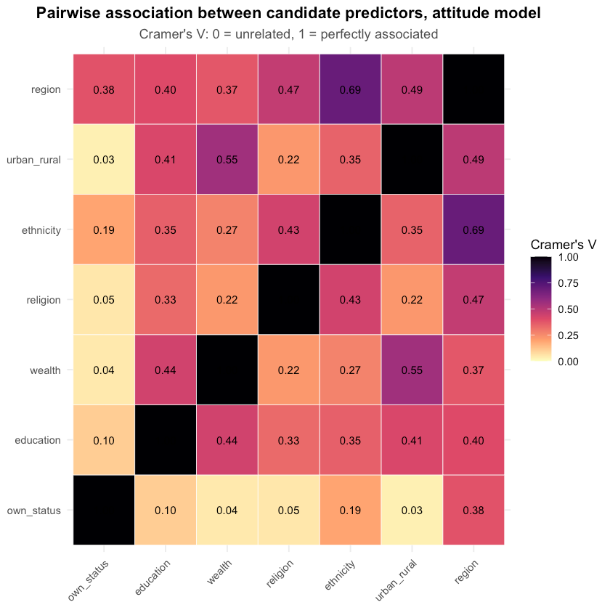

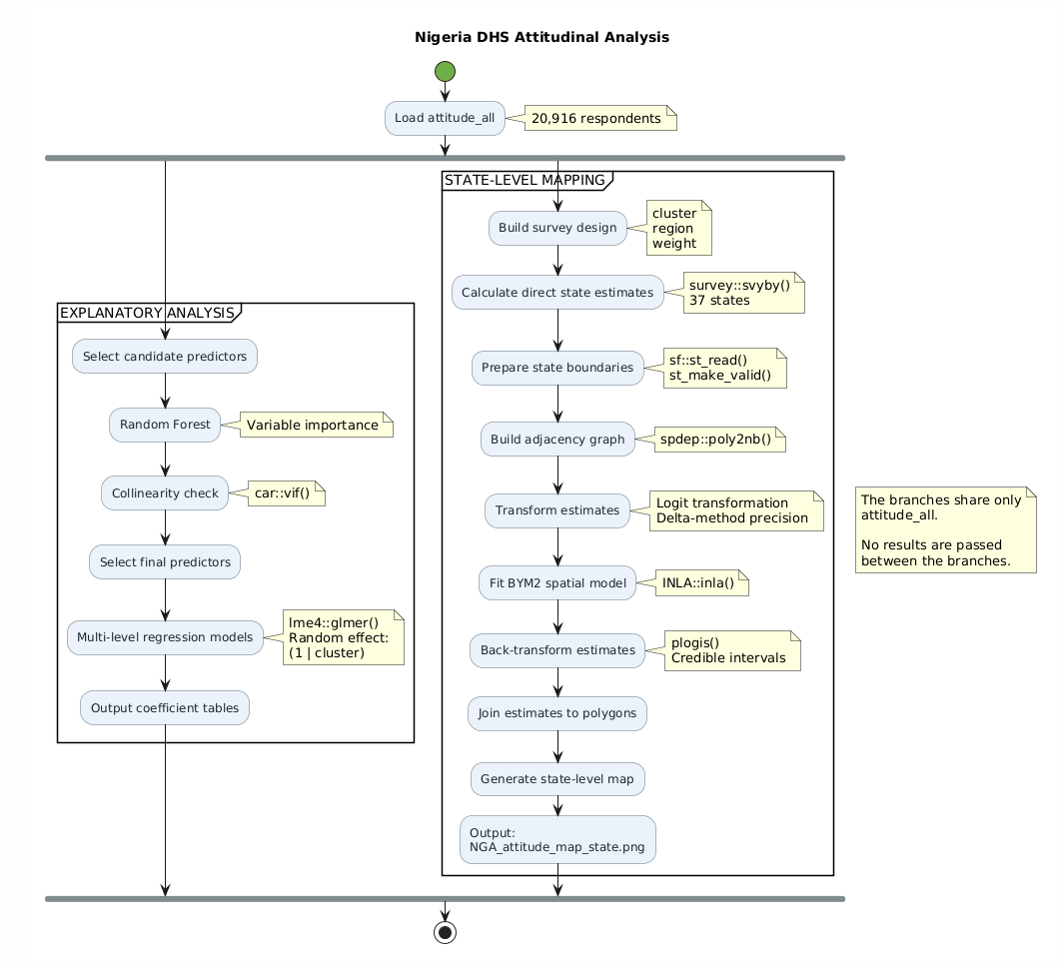
- Results
A comparison of the risk incidence and the attitude incidence results show a strong positive correlation coefficient of 0.74. This suggests that states with higher estimated FGM risk generally tend to have a higher support for continuation. The relation is though not perfect as some states such as Sokoto and Kebbi, which have higher support for continuation but the estimated risk is relatively low. Attitudes and actual practices are related but not identical. This correlation should not be interpretated as evidence of causation.
State | Attitude support | Latest risk (2020–2024)
Katsina | 57.8% | 20.2%
Jigawa | 46.1% | 17.1%
Kwara | 37.1% | 14.1%
Kaduna | 50.1% | 12.2%
Kano | 35.3% | 8.7%
Nasarawa | 33.8% | 8.5%

